Sweet potato muffins

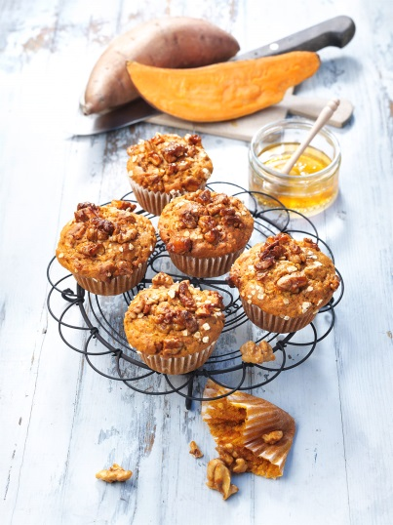
Ingredients for 12 muffins:
Approx. 300 g sweet potatoes from North Carolina
200 g walnut kernels
100 ml honey, preferably orange blossom honey
20 g butter
30 ml whipped cream
80 ml walnut oil
50 g macadamia cream
2 eggs (size L)
2 sprigs rosemary
125 g flour, type 405
50 g oat flakes, fine leaf
2 teaspoons baking powder
1 teaspoon cinnamon blossom powder, alternatively cinnamon powder
¼ TL Vanilla Powder
2 pinches salt

Also:
12 paper molds

Directions:

- Preheat oven to 180 °C (top and bottom heat). Wrap sweet potatoes in aluminium foil and cook in the oven for approx. 60-80 minutes (test them). Then remove and scoop out the flesh - 200 g are needed.

- Coarsely chop or break walnuts and lightly roast them in a pan (or in the oven) without fat, then caramelize them with 40 ml honey, butter and cream. Then leave to cool on baking paper and chop again coarsely.

- Puree the sweet potatoes with walnut oil, macadamia cream, the remaining honey and eggs. Remove the rosemary from the twigs and chop finely. Mix with flour, oat flakes, baking powder, cinnamon blossom powder, vanilla powder and salt and fold into the mashed sweet potatoes using a spoon. Finally fold in half of the caramelized walnuts.

- Line a muffin tin with paper molds. Spread the dough on the paper cups and place the remaining walnuts on top. Bake the muffins for 22 minutes on the middle shelf, then remove and enjoy while still warm.

Preparation time: 30 minutes + 100 min. baking time

Nutrition facts per serving:
Energy: 330 kcal/1380 kJ
protein: 6 g, fat: 23 g
Carbohydrates: 23 g

