Sweet potato couscous with pomegranate seeds and almonds
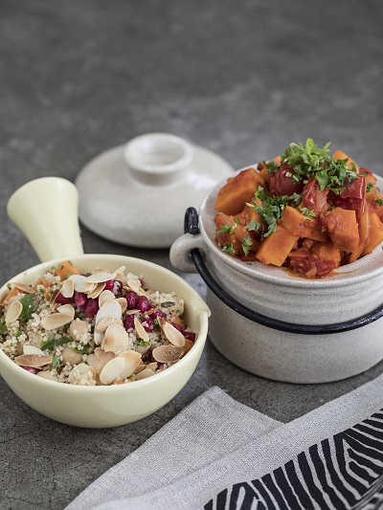
Ingredients for 4 servings:

1 large sweet potato from North Carolina
olive oil
salt
240 g couscous
350 ml water
½ Vegetable stock cubes
1 tbsp butter
1 can chickpeas (400 g), cooked, washed and drained
4 tbsp smooth parsley, finely chopped
4 tablespoons mint, finely chopped
1 small pomegranate
grated peel and juice of 1 lemon
3 tbsp planed almonds, roasted

Preparation:

- Preheat the oven to 250 °C. Peel sweet potato and cut into 1 cm cubes. Grease an ovenproof dish with butter. Add diced sweet potatoes and mix with a little olive oil and salt. Bake in the upper part of the oven for approx. 15-20 minutes.

- Place couscous in a bowl and mix with a little olive oil. Bring water to a boil in a pot and add the stock cubes and the butter. Then pour the stock over the couscous and stir. Let is simmer for 5-10 minutes.

- Loosen up the couscous with a fork. Add sweet potato cubes, chickpeas, parsley, mint, grated lemon peel and lemon juice and stir carefully. Sprinkle with pomegranate seeds and roasted almonds before serving. It goes well with a vegetable tagine.

