Spicy sweet potato cabbage salad

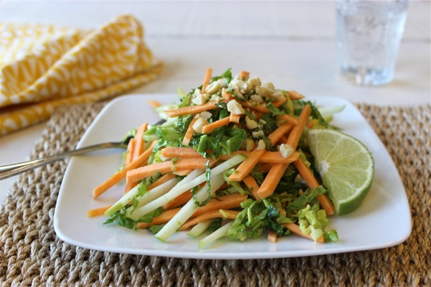
Ingredients (4-6 servings):

1 large sweet potato from North Carolina (300 g)
2 tablespoons lime juice
2 tablespoons sesame oil
1 tablespoon rapeseed oil
1 teaspoon fresh ginger, grated
1/2 teaspoon salt
1 Granny Smith apple
125 g savoy cabbage
1 spring onion
1 to 3 teaspoons Jalapeños
1 tablespoon fresh coriander
30 g roasted peanuts, chopped

Directions:

1. Mix lime juice, sesame oil, rapeseed oil, ginger and salt in a bowl.

2. Peel sweet potato. Cut apple, savoy cabbage and sweet potato into thin julienne strips. Chop the spring onion, the coriander and the jalapeños finely. Add sweet potato, apple, savoy cabbage, spring onion, jalapeños and coriander to the dressing and mix well.

3. Arrange on plates and sprinkle with peanuts. Garnish with a slice of lime as desired.

Preparation time: approx. 45 minutes.

Nutrition facts per serving:
Energie160 kcal/670 kJ
Eiweiß3 g
Fett8 g
Kohlenhydrate18 g

