Sweet potato buddha bowl with chicken breast

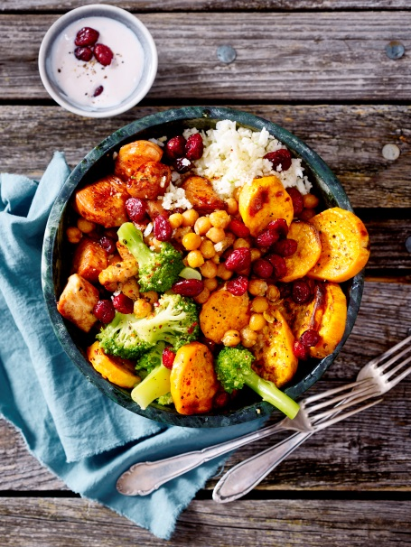
Ingredients for 4 Persons:
700 g sweet potatoes from North Carolina
1 can (400 g) chickpeas
9 tbsp oil
1/2 tsp grounded coriander
1/2 tsp cumin
Salt
Pepper
200 g whole milk yoghurt
150 g dried US cranberries
1 tbsp sugar
Juice of half a lemon
50 ml cranberry juice
4 chicken breasts (à ca. 150 g)
2 (à ca. 400 g) cauliflowers
1 (400 g) broccoli

Also:
baking tray
baking paper

Directions:

- Drain chickpeas. Mix chickpeas, coriander, cumin and ½ tsp. of salt in a bowl. Spread chickpeas onto half of the baking tray. Peel, wash and cut sweet potatoes into 0,5 cm slices. Place them next to the chickpeas. Drizzle the potatoes with oil and season with salt and pepper. Bake for 20 minutes in the preheated oven.

- In the meantime, blend yoghurt with 2 tbsp cranberries, sugar, lemon juice and cranberry juice. Season with salt and pepper.

- Wash the meat, tap dry and cut into bite-sized pieces. Season with salt and pepper. Heat up 4 tbsp oil in a pan. Fry the meat for 4 minutes while turning. Take out of the pan.

- Wash cauliflower. Grate the florets finely from the stalk. Cut the broccoli florets from the stalk, wash and cook in boiling salted water for 3-4 minutes. Take out the broccoli. Cook grated cauliflower for ca. 4 minutes into boiling salted water. Strain through a sieve.

- Arrange chickpeas, sweet potatoes, cauliflower, broccoli and remaining cranberries in bowls and add the chicken on top. Serve with cranberry yoghurt dip.

Preparation time: ca. 40 minutes

Nutrition facts:
Energy: 870 kcal / 3650 kJ
Protein: 51 g
Fat: 29 g
Carbohydrates: 93 g

